Assessment of Prince 5 as a Regional Oceanographic Reference Station for Local Herring Spawning Grounds; German Bank and Scots Bay

Abstract

Introduction
Within the Bay of Fundy and southwest Nova Scotia, Prince 5 is the only long-term oceanographic monitoring station with regular observations. Located on the northern side of the mouth of the Bay of Fundy, east of Campobello Island and north of Grand Manan Island in approximately 100 m of water, the station has served as a key site for oceanographic monitoring for over a century (Page, Ringuette and Hanke, 2000). Named in honour of the pioneering Canadian scientist Edward E. Prince, oceanographic observations at Prince 5 date back to at least 1913, making it one of the longest-running marine monitoring programs in Canada (Page, Ringuette and Hanke, 2000). Near-monthly vertical profiles of temperature and salinity have been collected almost continuously since 1921, providing an exceptional record of environmental variability in the region (Page, Ringuette and Hanke, 2000). In recent decades, sampling frequency has increased, with hydrographic profiles often collected at approximately two-week intervals.
The Southwest Nova Scotia/Bay of Fundy herring stock has two primary spawning grounds within the region: Scots Bay, located in the inner Bay of Fundy, and German Bank, located southeast of Yarmouth, Nova Scotia. These spawning grounds range in depth from approximately 60 to 80 m. Although they are not sampled oceanographically on a regular basis by the Department of Fisheries and Oceans, they are covered sporadically during annual Research Vessel (RV) trawl surveys conducted in the Bay of Fundy and Scotian Shelf during summer. Since 2017, however, the Herring Science Council, an industry-funded science organization operated by purse seine quota holders, has collected oceanographic data directly on the spawning grounds at approximately biweekly intervals during their respective spawning seasons. Sampling in Scots Bay has generally occurred from June to September, while sampling on German Bank has generally occurred from August to November. Combining RV survey data with Herring Science Council observations provides an opportunity to evaluate Prince 5 as a reference station for the Scots Bay and German Bank herring spawning grounds, using average monthly means for temperature, salinity, temperature stratification, density, and density stratification.

Study area and oceanographic setting
Southwest Nova Scotia (SWNS) and the Bay of Fundy (BoF) are part of the Gulf of Maine system (Figure 1) and are characterized by strong tides and associated currents, especially in the inner Bay of Fundy where tidal amplitudes are among the largest globally. Current speeds are typically on the order of ~1 m/s in SWNS and 1–1.5 m/s at the entrance of the Minas Channel, increasing to as high as ~4 m/s in the narrows near Cape Split (Greenberg, 1982). Strong tidal mixing produces predominantly well-mixed conditions in much of the Bay (including areas around Grand Manan, Brier Island, and SWNS), while stratification is seasonally reduced during late fall through early spring as surface heating weakens and meteorological forcing increases (Greenberg, 1982). Mean circulation in the upper Bay is largely tidally driven, whereas freshwater runoff plays a larger role in the lower Bay; wave energy in the Bay is typically low (Greenberg, 1982).

Modern comparison results:
Best evidence for Prince 5 as a reference station is for temperature. Scots Bay temperature tracks with Prince 5 extremely well. German Bank also tracks reasonably well but with more scatter.
German Bank is on average, 0.301°C cooler than Prince 5. Scots Bay is on average 0.250 warmer than Prince 5.
Prince 5 is not a good reference for salinity or density.
For temperature stratification, German Bank is more stratified by Prince 5 by 0.86°C on average. For Scots Bay the mean difference is small but tracking is weak. Prince 5 does not track Scots Bay temperature stratification well over time.
For density stratification, Prince 5 does not look like a good reference station, especially for Scots Bay.

Paired year-month comparisons indicated that Prince5 tracked temperature variability at the comparison grounds reasonably well, particularly for Scots Bay. Monthly mean temperature at Scots Bay was strongly correlated with Prince5 values (r = 0.938, n = 27), with a small positive mean difference of 0.25°C and an RMSE of 0.74°C. German Bank temperature was also positively correlated with Prince5 temperature (r = 0.745, n = 22), although with greater error (RMSE = 1.14°C). In contrast, salinity and density showed little to no correlation between Prince5 and either comparison ground, suggesting that Prince5 does not adequately represent spatial variability in salinity-driven oceanographic conditions. Stratification metrics were also weakly correlated among grounds, indicating that local vertical structure differs among areas. Overall, Prince5 appears suitable as a reference station for broad temperature variability, especially for Scots Bay, but not for salinity, density, or stratification.
Prince5 appears to be an appropriate reference for regional temperature variability, particularly for Scots Bay, but it does not adequately represent salinity, density, or stratification dynamics at German Bank or Scots Bay.
Pearson Correlation (r) – measures whether the two locations change together through time. Range, +1 perfect tracking, 0 = no relationship, -1 opposite behaviour
Variable | Ground | r
Temperature | Scots Bay | 0.938
Temperature | German Bank | 0.745
Everything else | Both grounds | ~0 to 0.3

RMSE – root mean square error, measures the typical size of prediction errors. Lower is better. Formula is sqrt(mean(difference^2)). Because differences are squared, large discrepancies are penalized heavily. RMSE of 0.74°C means typical disagreement between Scots Bay and Prince 5 is about 0.74°C.
MAE – Mean absolute error, mean(abs(difference)), measures the average absolute difference. Unlike RMSE, it does not heavily weight large discrepancies, for a MAE of 0.548, the average month-year pair differs from Prince 5 by about 0.55°C.
Strong evidence
Prince5 is an excellent reference station for Scots Bay temperature and a reasonably good reference station for German Bank temperature.
Moderate evidence
Prince5 may provide a general indication of broad regional thermal conditions.
Weak evidence
Prince5 cannot be considered a reliable reference for:
- salinity
- density
- temperature stratification
- density stratification
because correlations are weak or absent despite reasonable sample sizes (18–27 paired observations).
Monthly mean temperature at Prince5 was strongly correlated with temperatures at Scots Bay (r = 0.94) and German Bank (r = 0.75), suggesting that Prince5 provides a useful indicator of regional thermal variability. In contrast, salinity, density, and stratification metrics exhibited weak correlations among grounds, indicating that Prince5 does not adequately represent spatial variability in these oceanographic properties.

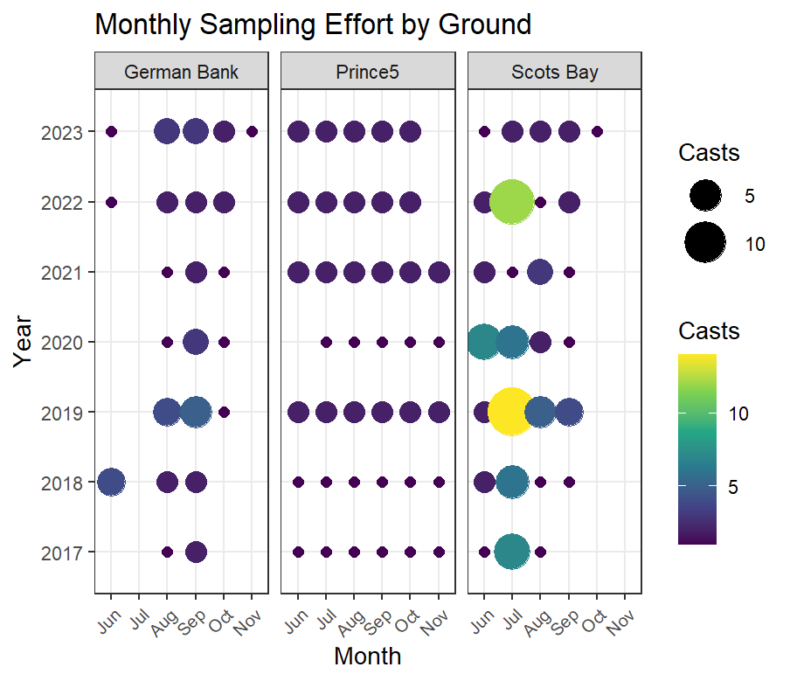
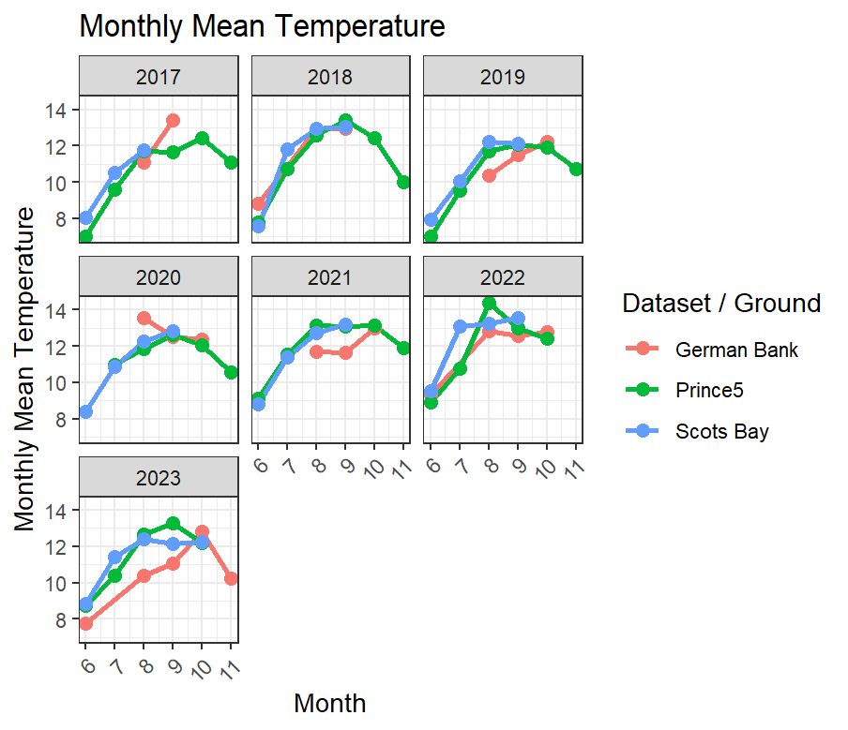
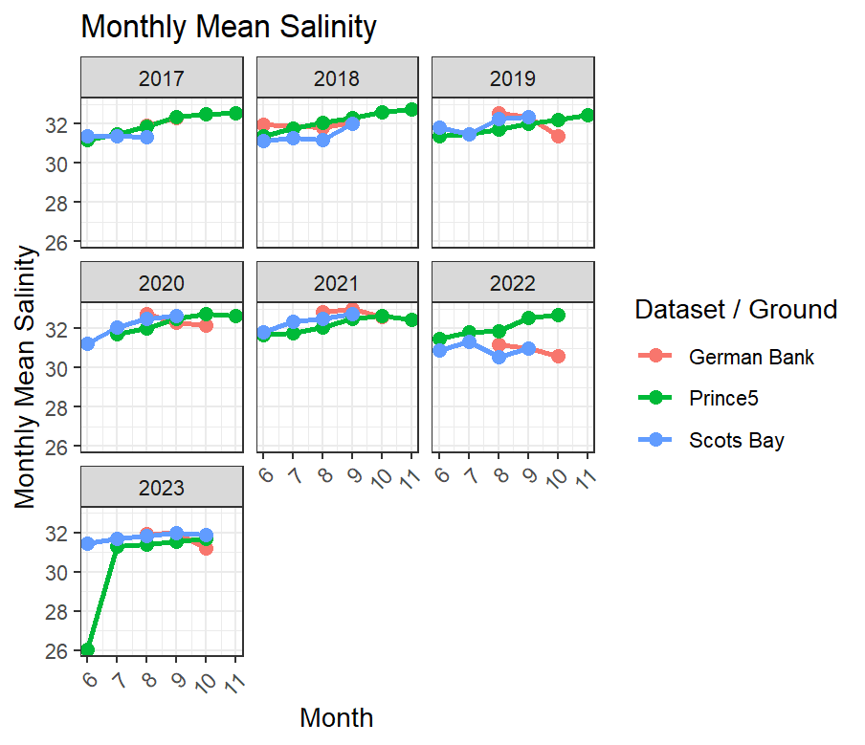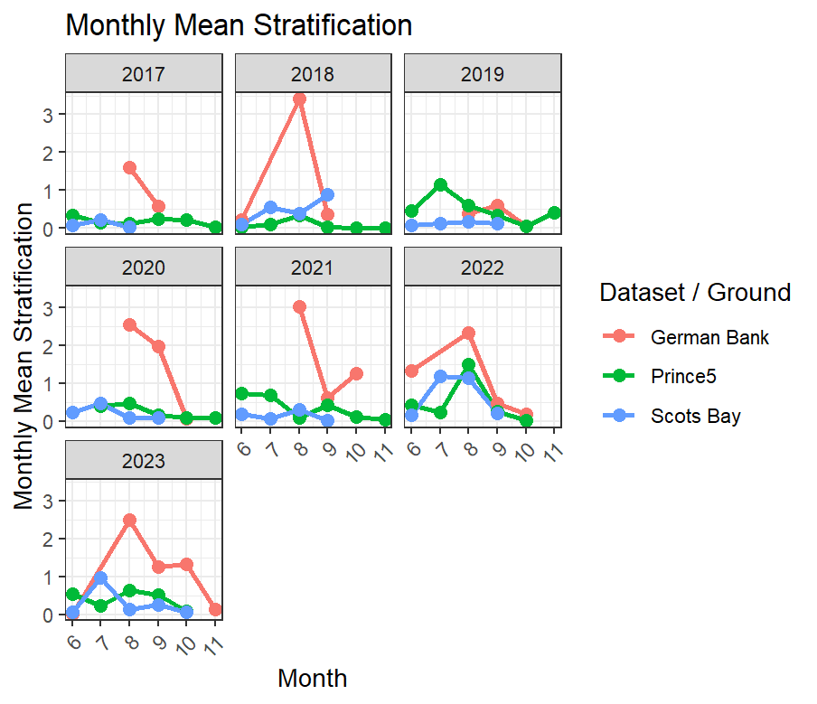
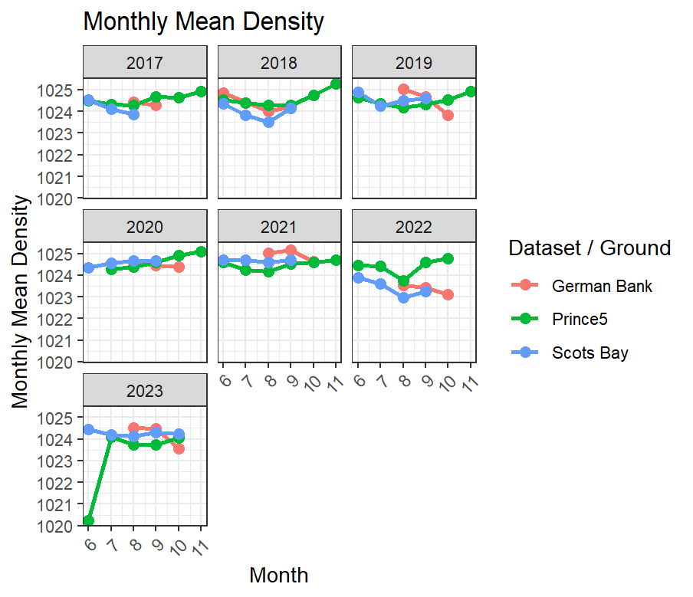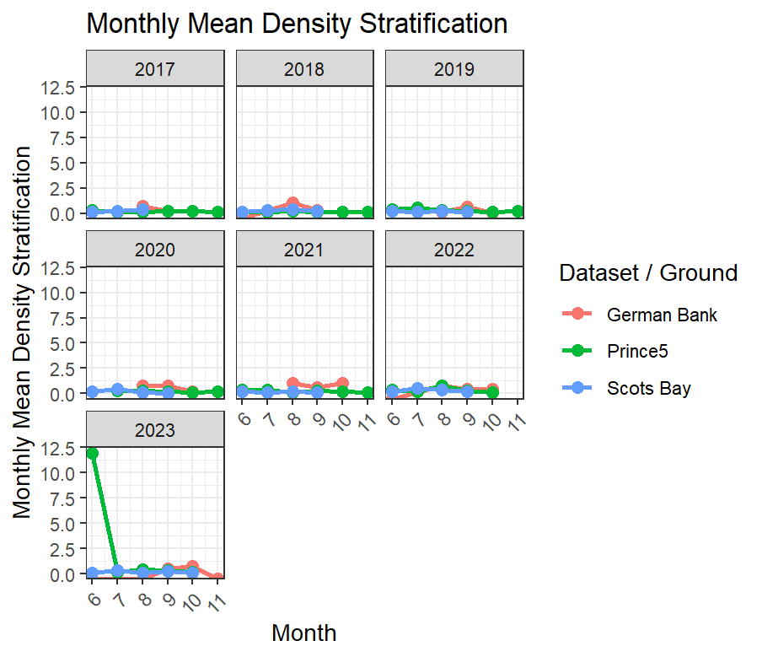
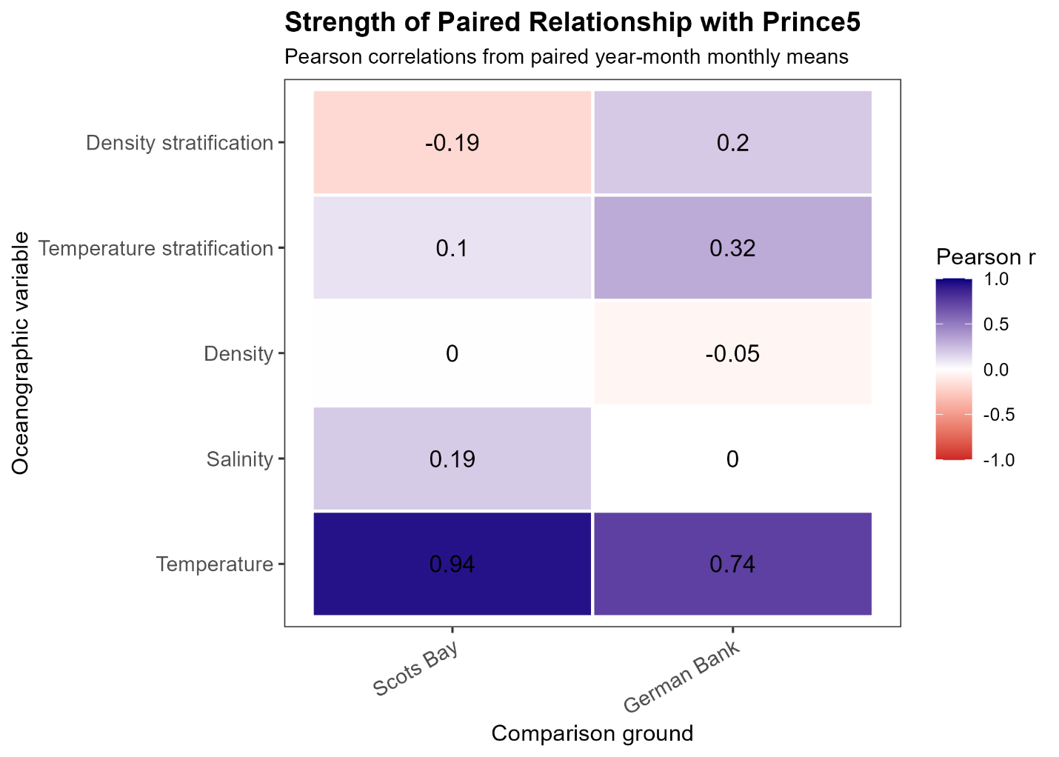
rank | variable_label | comparison_area | n_paired | pearson_r | mean_difference | rmse | mae
1 | Temperature | Scots Bay | 27 | 0.938 | 0.250 | 0.741 | 0.548
2 | Temperature | German Bank | 22 | 0.745 | -0.301 | 1.140 | 0.928
3 | Temperature stratification | German Bank | 22 | 0.316 | 0.861 | 1.293 | 0.933
4 | Density stratification | German Bank | 18 | 0.197 | 0.341 | 0.458 | 0.360
5 | Salinity | Scots Bay | 27 | 0.193 | 0.159 | 1.189 | 0.644
6 | Temperature stratification | Scots Bay | 27 | 0.104 | -0.107 | 0.461 | 0.367
7 | Salinity | German Bank | 20 | 0.001 | -0.113 | 0.761 | 0.580
8 | Density | Scots Bay | 27 | -0.003 | 0.083 | 0.940 | 0.521
9 | Density | German Bank | 20 | -0.047 | -0.039 | 0.661 | 0.526
10 | Density stratification | Scots Bay | 27 | -0.187 | -0.499 | 2.288 | 0.593

